The Art Of Electronics Notes
Christopher Kalitin

“Nonmathematical treatment”

Preface To The First Addition
Handbook syndrome: excessive detail
Cookbook syndrome: oversimplification

This is the art, not the theory, of electronics.

“at most, back-of-the-envelope calculation”

Preface To The Second Addition
Neophyte: an individual new to a field

Preface To The Third Addition
First words:
“Moore’s law continues to assert itself, unabated”

ONE: Foundations

1.2: Voltage, Current, And Resistance
1.2.1: Voltage and Current
Voltage is the cost in energy is move a positive charge from a negative point to a more positive point (low to high potential).

“Cost in energy” = work

In electronics, roughly intuitively: voltages are what you apply to get currents to flow.

Voltage = electromotive force. They are the exact same topic.

Current flows through things. Voltage is applied across two points.

“Voltage through a resistor” is nonsense. Instead, “voltage across a resistor.”

Voltage generation by conversion from:
- Electrochemical energy (battery)
- Mechanical energy (generators)
- Photovoltaic (solar cells)

We get currents by placing voltage across things? This is what V=IR means! Ohm’s law!

Kirchhoff’s current law: sum of currents into a node equals sum of currents out.
Kirchhoff’s voltage law: sum of voltage drops over any closed circuit is zero.

P = VI
energy/charge * charge/time = power = energy/time

Ohmage = resistance but only if you work with giant 13kV transformers.

1.2.2: Relationship between voltage and current
“The name of the game is to make and use gadgets that have interesting and useful I-versus-V characteristics.”

Thicker gauge wire means lower voltage drop from lower resistance.

4 digit SMD codes are in units of 0.010” (0.25mm).

Resistors are either metal-oxide film, metal film, or carbon film.

“Roughly speaking, resistors are used to convert a voltage to a current, and vice versa.”
Vice versa! Resistor current sensor!

Resistors: from carbon-composition or ceramic-composition moldings, or metal foil or metal wire wound on a form (huh? inductor?), or from semiconductor elements.

Resistors may have high inductance and high frequencies, not perfect.

Most SI prefixes are greek, but milli is latin for thousand and pico is italian/spanish for small.

International alternative notation: replace the decimal point with the unit multiplier. Eg. 4k7 or 1M0. 2.2ohms -> 2R2. Analogous schemes for capacitors and inductors.

“Beginners tend to get carried away with complicated algebra [...]. Now is the time to begin learning intuition and shortcuts.”

You can trim a large resistor but putting it in parallel with a smaller resistor. This circuit has roughly the resistance of the smaller resistor. Works in series too!

Eg. to lower resistance by 1%, put a resistor 100x as large in parallel.

To simplify parallel resistor circuits, put them in the same quantitative units. (eg. 5k resistor is two 10k resistors, now its easier to compare with another parallel 10k).

“One mark of a good circuit design is insensitivity of the finished circuit to precise values of the components.”

Sometimes easier to think in conductance instead of resistance: G = 1/R

Eg. for a parallel circuit the new current is sum of individual currents. Hence, net conductance is the sum of the individual conductances (G = G_1 + G_2 + … + G_n), this makes that parallel resistance formula make more sense.

Siemens is the unit of conductance. “Engineers are fond of defining reciprocal units.”

Power scales with the square of current and square of voltage but reciprocally with resistance.

P = I²R is used for transmission losses.

H is the transfer function. Eg. 100x amplifier has H = 100.

Voltage divider = “de-amplifier”

1.2.3: Voltage dividers
Convention: signal flow left to right. Consider this in your schematics.

A resistor before a potentiometer is used to control volume in some circuits.

Some circuit has long chain of equal-value resistors with electronics switches. This gives electronic control of the voltage ratio (rather than mechanical control).

You could get an amplifier from a voltage divider if you had a negative resistance. Not actually crazy. Tunnel diode or negative-impedance converter.

There exist integrated potentiometers with 256 steps! E²POT

1.2.4: Voltage sources and current sources
Voltage sources perform more perfect with low resistances. (perfect in the approximation sense).

There is a max current of batteries, probably chemically determined.

Now what is com:
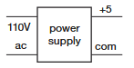

“A battery is a real-life approximation to a voltage source (there is no analog for a current source).”

A standard D-size flashlight cell has a terminal voltage of 1.5V and internal resistance of 0.25 Ohms. This declines with life to 1V and several ohms.

1.2.5: Thevenin equivalent circuit
Thevenin theorem: any two-terminal network of resistors and voltage sources can be perfectly modelled as a single resistor in series with a single voltage source.

Norton’s theorem: same thing can be done with a single current source in parallel with a resistor.

Open-circuit voltage: voltage across output terminals when no load or resistance is connected. No current flow. This is what you calculated in 158, it’s simple.

Short-circuit current: current that flows when output terminals are connected.

Finding thevenin equivalent voltage source and resistor:
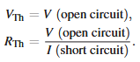

Reasons thevenin equivalent circuits are useful:
- When adding a load, it’s very easy to calculate output voltage, current, power, etc. It’s simplified

Most multimeters have input resistances of 10-1000 Mega ohms.

Different voltage ranges on multimeters have different input resistances. Eg. 10^9 on the 0.2V and 2V lines and 10^7 ohms above that.

Ammeters have a few tenths of a volt of drop.

Power supply = voltage source.

The reason a voltage divider would make a bad battery is because it is has the equivalent of a high internal resistance. This means it isn’t a very stiff voltage source (bends under load). You can get internal resistances as small as milliohms in voltage sources using active components.

If you add a load that is at or below the internal resistance of your supply, you get considerably reduced output. “Circuit Loading.” Solution: R_{load} >> R_{internal}

“Despite warnings like “don’t anthropomorphize computers … they don’t like it.””

Max power your the load resistor occurs when R_{load} = R_{soruce}. R_{load} = infinity means 0 power, R_{load} = 0 means 0 power. P = IV

When I is not proportional to V, we can’t use ohm’s law and resistance. Since the ratio V/I will depend on V and isn’t a nice constant. However, the slope of the V/I line is in ohms.

1.2.6: Small-signal resistance
Small-signal resistance or incremental resistance is the small change in the V/I curve. Very small step. In unit ohms.

A zener diode operates in reverse bias. When the zener voltage is reached, it starts conducting current (backwards, in the reverse direction). This gives you a constant voltage output.

The zener diode provides another current path such that the voltage output will be kept constant. It makes up for the difference between input voltage and output voltage.

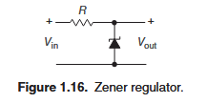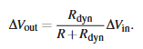

For a change in voltage, the circuit behaves like a voltage divider where you model the zener diode as a resistor with resistance equal to the dynamic resistance at a given operating current.

There are voltage reference ICs that perform better than zener diodes.

1.2.7: An example
Comparator: switches output according to relative voltage at two input terminals.
Vx > Vy: output high
Vx < Vy: output low

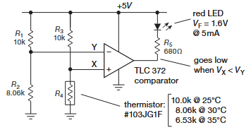
This circuit turns on an LED for temperatures greater than 30C. Notice that when T>30C, the voltage X drops below Y (this is how a voltage divider works, with a lower second resistor) and the LED turns on.

The LED works like a zener diode with a 1.6V drop. So the output is 3.4V (5-1.6 V). To size this circuit to allow 5mA, we choose R = V/I = 3.4/0.005 = 680 Ohms.

They call it a “pot” too!

Hysteresis should be added to encourage the comparator to be decisive. More on this later.

The circuit above is ratiometric, so it doesn’t rely on the exact input voltage. Ratiometric!

1.3: Signals
Finally back to something I can understand. That circuit above is cool though. Also good to see more about the voltage drop over an LED.

1.3.1: Sinusoidal signals
Frequency response = how a circuit alters amplitude of a sine wave as a function of frequency. Eg. a stereo has a flat frequency response over 20 Hz to 20 kHz, at least. I think this corresponds to no distortion in volume.

1.3.2: Signal amplitudes and decibels
Peak-to-peak amplitude is twice the amplitude. (top to bottom, it’s really peak to trough).

RMS only works in the ratio 0.707 (1/sqrt(2)) for sine waves. For other waves, the ratio of pp to rms is different.

Remember: amplitude of AC in North America is 163 V!

Decibels ordinarily refer to the ratio between two signals, when its used as an absolute measurement some reference level is used. Eg. 1V rms = 0 dB V

In acoustics, 0 dB SPL (sound pressure level) is a wave whose rms is 20 micro pascals.

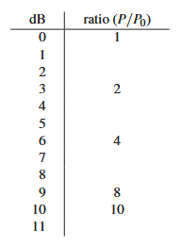

1.3.3: Other signals
Band-limited white gaussian noise: equal power per hertz in a band of frequencies and a bell curve distribution of amplitudes.
This type of noise is generated by a resistor (John or Nyquist noise) and it shows up in many places (eg. oscilloscope).

Edges of square waves aren’t fully square.
Rising time of a square wave is the time from 10% to 90%.
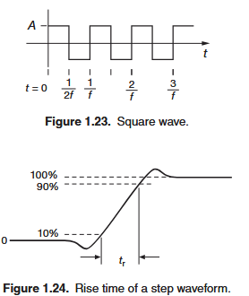

1.3.5: Signal sources
Types: signal generators, pulse generators, function generators.

Signal generators are sine wave oscillators.

Amplitude control is done by a resistive divider network (attenuator!).

AM = frequency modulated
FM = frequency modulated

Pulse generator parameters: pulse width, repetition rate, amplitude, polarity, rise time, etc.

Traditionally, function generators used analog circuitry. What that must have been like! Now they’re all digital.

1.4: Capacitors and ac circuits
1.4.1: Capacitors
Capacitors used to be called condensers.

Pair of 1 cm^2 plates 1 mm apart would give a single pico farad. Good perspective on how small the internals of capacitors have to be.

“To a first approximation, capacitors are simply frequency-dependent resistors.”

Blocking capacitor (also known as coupling capacitor):
In series with a DC signal, it blocks the average DC voltage and lets through a varying signal.

Bypass capacitor:
Because caps act as shorts at high frequencies, it can suppress AC signals.

Bypass capacitors are so taken for granted that they are usually omitted from schematic diagrams. Don’t make this mistake with real circuits!

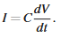
This equation means that if you supply a 1uF capacitor with 1mA, voltage will rise at 1000 volts per second.

Remember the formula for energy stored in a capacitor (proportional to V²):
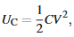

Thin ceramic wafers are a type of capacitor (ceramic chip).
Electrolytic capacitors are metal foils with oxide insulators.

Each type of capacitor has unique properties. In chapter 1x of the supplementary text.

1.4.2: RC circuits: V and I versus time
Two approaches for dealing with ac circuits:
- V and I versus time.
- Amplitude versus signal frequency.

Discharging capacitor:
Current flow is proportional to the remaining voltage.
The slope of the discharge is proportional to that current (from the capacitor equation).
So the discharge curve is a function whose derivative is proportional to its value (an exponential).

Remember the 5RC rule of thumb: Capacitors discharge to 1% after 5 time constants.

You don’t actually need to manually analyze and compute large RC circuits, just get the thevenin equivalent!

A CMOS takes in a logic level, and outputs exactly the corresponding voltage. Eg. 0.4V input outputs 0 V. 2.9V gives you 3.3V.

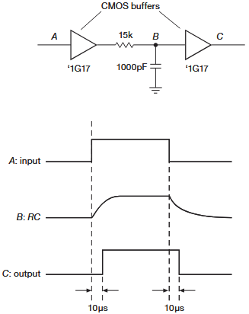
With this circuit, you can delay the output of a digital signal by a set time. Useful trick in some circuits to ensure something else happens first.

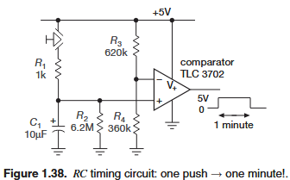

Notice that all the mini RC circuits we’ve seen so far have C and R parallel to each other and going to ground! This is what I wasn’t understanding in my circuit! (Scribe capacitance meter testing)

In this circuit, the comparator output is ground while the + pin is less than the - pin. The - pin is set to exactly 0.37 of the positive voltage. So, when the button is pressed the capacitor is quickly charged, then it discharges with a time constant of 1 minute, at that point the comparator output returns to ground. Note that charging time constant and discharge time constant are different!

Note that for R₂ the closest standard value to 6MOhms is used, which is 6M2. You could trim it if you wanted to with a resistor in parallel. (This would actually require a 190 megaohm resistor).

Remember this note: “Eg. to lower resistance by 1%, put a resistor 100x as large in parallel.”

In the circuit above you could omit R1 but you’d get a large transient current when charging the capacitor.

Usually, comparators are coupled black to the input such that switching is enforced (to avoid noise resulting in bouncing). This is called hysteresis or positive feedback.

Usually, in DC circuit you bypass the dc supply by connectors capacitors between the dc rail and ground. Capacitance is non-critical, 0.1 to 10 uF.

1.4.3: Differentiators
These circuits literally differentiate an input signal. Vout proportional to the time derivative of Vin.

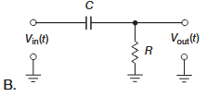
This circuit gives you an output current proportional to the current through the capacitor. It’s not a perfect mathematic differentiator because the voltage across C is not equal to Vin (if we had only a capacitor, it would be).

You make the product RC very small such that the derivative of the output voltage is much smaller than the derivative of the input voltage (second derivative?). Then, you can get something like this:
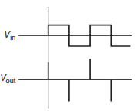

These can be used as edge detectors for pulses.

Current pace today: 16 pages in about 4 hours of net time (including shower, breakfast). 15 minutes per page on net. In 10 hours this is 40 pages. Full book in 25 days.

Differentiators can sometimes come up unexpectedly. Eg. if you have a square wave coupling capacitively to your signal line you get the first image below. Or, if you’re observing a square wave but didn’t put the probe on right and theres some capacitance (image 2):
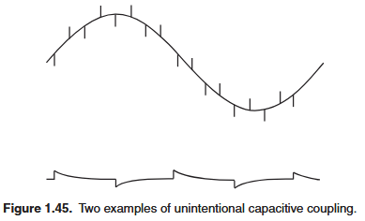

1.4.4: Integrators
We’ve seen that a series capacitor is a differentiator and we get the output via a the voltage drop over a resistor to ground.

A parallel capacitor is an integrator.

The integral of input current is voltage. To convert this voltage into a current, you use a resistor in series.

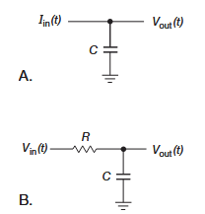

If you keep V << Vin, you get:
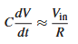

By extension:
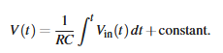

This means you want a very large RC to make your circuit B (approximate integrator) as close to ideal as possible. Since with the resistor current through C is not longer proportional to Vin.

Saying V << Vin is equivalent to saying I is proportional to Vin.

Integrators are used in analog-digital conversation, waveform generation, control systems, feedback, etc.

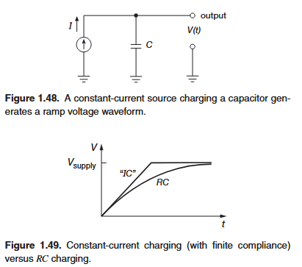

1.4.5: Not quite perfect
All capacitors have some series resistance and series inductance.

Dielectric absorption is a “memory” effect where if you charge a capacitor to V0, discharge to 0V, remove the short, it drifts back a bit to V0.

1.5: Inductors and Transformers
1.5.1: Inductors
This is a parallel capacitor:
This is an inductor with a magnetic core:

Rate of current change in an inductor is proportional to the voltage applied across it.
Rate of voltage change in a capacitor is proportional to current through it.

Inductance is the ratio of magnetic flux passing through the coil divided by the current though the coil that produces that flux. Flux over current.
Inductance is proportion to the number of wires squared.
L ∝ n²

A coil with some length is known as a solenoid.

Practical inductors differ from ideal performance significantly (winding resistance, core losses, self-capacitance). Practical capacitors are nearly perfect.

An inductor with a voltage source that has a 50% duty cycle will output exactly half of the input voltage. This is the same behaviour as a voltage divider but without energy losses! Is the waveform actually flat?
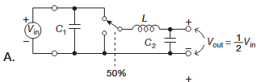

You can also do this in reverse, to make the output voltage twice the input:
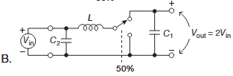

Why are the capacitors there? Storage capacitor for steadying output voltage. See chapter 9 for what these circuits actually do.

1.5.2: Transformers
Symbol:
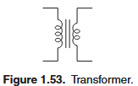

Transformers isolate.

High-frequency transformers require special core materials and construction to minimize core losses. Low-frequency transformers (eg. ac powerline transformers) require heavy and large cores.

Inductors have a magnetizing inductance. This is the reason you can’t make a dc transformer.

1.6: Diodes and diode circuits
Earlier was time-domain capacitors and inductors, now we got into the frequency domain.

1.6.1: Diodes
Nonlinear device, unlike res, cap, ind. Doubling applied signals does not produces a doubled response.

Anode = positive = higher potential = input
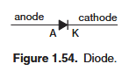

Anode comes before Cathode in the alphabet. Alpha Beta. A C. Positive before negative. Anode before cathode. Remember! Just go alphabetical order.

This book will not describe the solid-state physics that make such devices work.

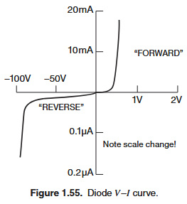
To read this chart, consider the current running through your diode, then find where on the graph this corresponds to. Eg. 10mA flowing forward from anode to cathode corresponds to ~0.6V forward voltage drop.

Diodes don’t have a resistance since they don’t obey ohm’s law. If you put one in a circuit, it won’t have a Thevenin equivalent.

1.6.2: Rectification
AC -> DC

Most AC circuits are powered by a transformer from the wall.

Half-wave rectifier:
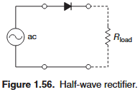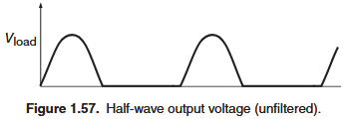

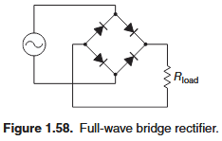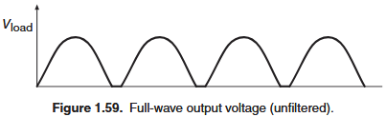

Notice that on a full bridge rectifier, the return current only flows through one of the diodes because the potential on the other end of the diode determines if current flows. So it can’t flow into the direction current is coming from.

Also, notice the clipping at the bottom of the waveform, this is due to the forward voltage drop.

Active switching with transistor switches solves the diode drop problem.

1.6.3: Power-supply filtering
A capacitor is added between the positive and negative of the full-wave bridge rectifier to reduce the amplitude of the ripples.

Note the ripple frequency is 120 Hz, because the AC input is 60 Hz.

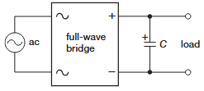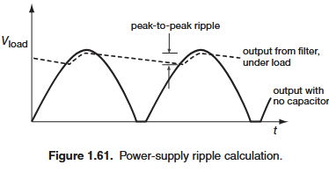

To calculate ripple voltage we use the fundamental capacitor equation:
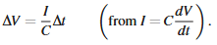

We 1/f (or for full bridge 1/2f) for dt:
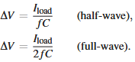

Lmao!
“While teaching electronics we’ve noticed that students love to memo-
rize these equations! An informal poll of the authors showed that two
out of two engineers don’t memorize them. Please don’t waste brain
cells that way – instead, learn how to derive them.”

Power supplies are built with capacitors with tolerances of 20% or more. Design conservatives for the manufacturing spread.

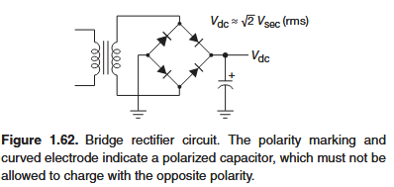

1.6.4: Rectifier configurations for power supplies
This rectifier is slightly less efficient that the full wave rectifier above because the inductor is only used half the time and you get power losses. I don’t actually understand.
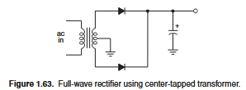

You have 2x power for a 50% duty cycle instead of 1x power for 100% duty cycle. Losses: P = I²R, so you get 2x higher losses.

Dual polarity split supply:
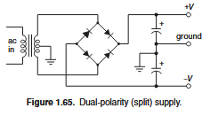
I can’t picture this one either. What is the ground doing? Where does current flow?

LLMs:
A center tap is a connection point in the middle of a winding. It’s physical. It creates a neutral point since its in the middle.

Because inductors pick up potential as you go along the windings, the middle is a reference point to which both ends are -V and +V. Fundamental insight: inductors pick up potential as you go along the loops.

Remember: potential is all relative. We take ground as our reference, so +V and -V are sine waves that look like half wave rectifier outputs. Only for a half period are either rails being powered through the diodes, capacitors make up for the rest and make the output DC.

It is an issue if there’s only a load on +V and not -V. You get magnetic saturation which leads to inefficiency, heating, voltage drops, ripple, etc.

Sufficiently large capacitors reduce ripple to any arbitrary level. Bad because:
- Large capacitor money
- They only charge right at the top fo the waveform in a short interval, this means higher current, higher I²R losses.

A better solution is to use a capacitor to get within 10% of a DC output, then use a feedback circuit which looks at the output and uses a controllable series resistor (transistor) to keep the output voltage constant.

This is called a linear regulated dc power supply:
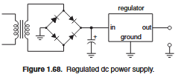

Many linear regulator ICs also have short circuit protection, overheating production, low internal resistance (milliohms), etc. Chapter 9.

1.6.6: Circuit applications of diodes
Schottky diodes has a forward drop of 0.25V. Good for some signals applications where you eg. want to see the rising edge of a square wave but the 0.6V forward voltage of a zener is too high for you.

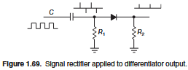

Diode gates! This one has a backup battery for an RTC in a computer that only powered the IC while it isn’t being powered externally by the 5V source!

Diodes don’t conduct unless the anode is at a higher potential than the cathode + forward voltage. Eg. 5V > 3V + 0.6V.
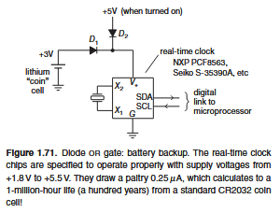

Diode clamps set a limit on what input voltage gets into a circuit:
This does gives a 5.6V limit and the resistor is there for current limiting.
The lower limit is the reverse break-down voltage of the diode, eg. -75V.
These are used in CMOS digital logic, without which static electricity would fry all components.
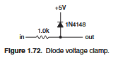

High internal resistance means a voltage source is not stiff. Low internal resistance = stiff. Just think of old batteries (not stiff and high internal resistance).

Diodes can also be used as limiters (haven’t we been over this? Isn’t it just a clamp? But in both directions!).
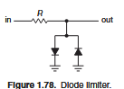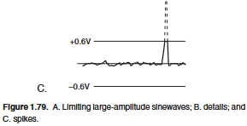

Silicon diode voltage drop decreases by 2mV / C

1.6.7: Inductive loads and diode protection
Remember that this is why inductors can’t stop current suddenly:
Stopping instantly would be infinite voltage across the inductors terminals.

If voltage over an inductor abruptly rises, you get a lot of current flow very quickly. Must protect against this.

Eg. if the switch is opened, the inductor tries to keep current flowing from A to B by increasing the potential of B.
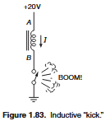

Grok:
Lenz’s law: inductor induces a voltage to oppose the change in current. Current was flowing from A to B and now it’s zero.

$V_{L}=L\frac{di}{dt}$

Because the change in current is in the negative direction (B to A), V_{L} is negative, so A must be lower potential than B, so B is higher potential.

In an inductor, if current suddenly stops, the voltage over the inductor is opposite to the original direction of the current. Back EMF is called back because it’s backwards when current stops.

There is no path for current flow, so current can’t flow from B to A due to the higher potential of B relative to A. The principle of high to low potential only applies when there is a conductive path.

Because the change is abrupt, you may get 1000V over the inductor.

The solution is to put a diode backwards over the inductor. In regular operation it is backwards biased and does nothing. When the switch stops, it provides a current path which means the inductor doesn’t need to create any crazy voltage at point B. The diode must be sized for the current that was flowing through the switch.
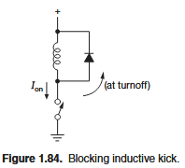

The rate of change of inductor current is proportional to the voltage across it, so the diode situation means the decay of current is longer.

Solution: put a resistor across the inductor and choose resistance such that V_{supply} + IR is less than the max allowable voltage at B (gate voltage for a switch, eg. transistor):
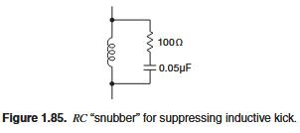

For inductors in AC circuits, diode protection won’t work because it’ll be conducting backwards half the time. The solution is an AC “snubber” network.

1.6.8: interlude: Inductors as friends
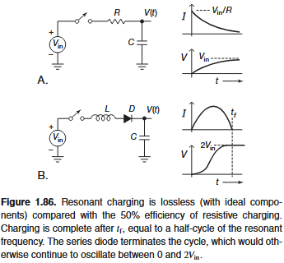

For charging a capacitor slowly you can do this with a resistor and lose half your energy, or with an inductor.

Grok:
Inductor capacitor charging circuit:
- LC circuit resonates at frequency f = 1/2pi*sqrt(LC)
- Capacitor reaches full charge after a half-cycle of the resonant frequency.
- The diode prevents current from flowing in the reverse direction.
- The cycle is terminated because no reverse current is allowed.
- Losses capacitor charging!

1.7: Impedance and reactance
All linear circuits have this property:
If driven with a sine wave, the output will be a winewave at the same frequency with at most a change in amplitude or phase.

Linear circuits contain: resistors, capacitors, inductor, linear amplifiers.

Because of this property, plotting the frequency response (ratio of output to input) versus sine wave frequency is useful.

Frequency response = ratio of output to input frequency

Eg. frequency response curve for a speaker:
Because you want it to be flat, you need to apply the filter shown
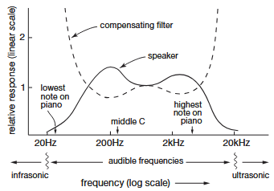

Ohm’s law is generalized by replacing “resistance” with “impedance.”

Capacitors and inductors are “reactive” components, hence they have a “reactance.”

“Impedance” covers everything. Reactance covers a single component. This is why you refer to a singe capacitors reactance and not its impedance.

Impedance can be used when talking about source resistance. It’s a more general term. Even if it’s only internal resistance, you can think of it as impedance.

Why does Fourier analysis work?

1.7.1: Frequency analysis of reactive circuits
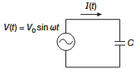
Consider a capacitor driven by a voltage source with this waveform:

Using the fundamental equation of a capacitor we get:

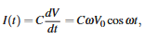

Solving for current we get:
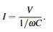

Wow! That’s why the capacitor current leads by 90 degrees! You differentiate and get cosine! This is why math class is important.

We take the magnitude and solve:
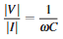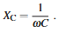

This is also why it’s in unit ohms. This was the derivation from the fundamental capacitor equation.

Would have been completely impossible for me to read this book before first year. What other books will I not be able to read until 2nd and 3rd year? Can I really read a math book on my own? I think yes, if it’s on the critical path.

When in doubt, remember the fundamental equation of a capacitor:
Current is proportional to capacitance and the change in voltage.
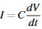

Doubling the capacitance of a capacitor, it takes twice as much current to charge/discharge. Hence, by V=IR, resistance is halved. Since R = Z = X_{C} = 1/wC, this makes sense!

This is an RC lowpass filter:
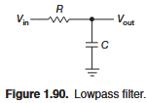

It passes low frequencies and blocks high frequencies. For high frequencies capacitive reactance is lower - X_{C} = 1/2pifC. So they have a lower impedance path to ground.

Lowpass and highpass filter frequency response curves:
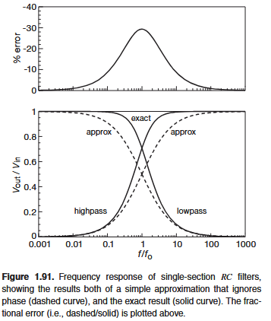

It acts like a voltage divider:
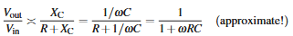

Highpass filter puts the capacitor in series:
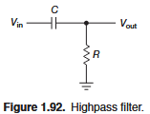

Numerator and denominator of the “voltage divider” is swapped:
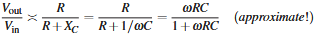

A highpass filter blocks DC, since DC effectively is AC with infinitely low frequency. This is what a blocking capacitor does.

In stereos you don’t know what DC level the inputs might be, so you put a blocking capacitor that you choose with a low enough frequency (eg. 5 Hz).

The resistor is required for lowpass / highpass filters because of the voltage divider.

Remember the two domains of capacitors: time domain nand frequency domain. This explains the various circuits I got for the capacitance meter and why they were in two different categories!

You want the circuit being driven to not significantly load the driving resistance (Thevenin equivalent source resistance). You would get a voltage drop.

Same goes for impedance, the impedance of the circuit should be high er than the voltage source. (Except for transmission lines and current sources).

1.7.2: Reactance of inductors

There must be a really interesting story of when PCBs first began to be introduced. I want to read a book on this.

1.7.3: Voltages and current as complex numbers
Unlike DC circuit, in AC you have to know about both the magnitude and phase shift of currents throughout the circuit.

We could use time series data to represent voltage and current everywhere (eg. V(t) = 23.7sin(377t + 0.38), or we can use complex numbers.

Vcos(wt + Φ) is represented by the complex number Ve^{jΦ}

e^{jΦ} = cos(Φ) + jsin(Φ)

Obtain real voltages and currents by multiplying by e^{jwt} and taking the real part

V(t) = Re(Ve^{jwt})
I(t) = Re(Ie^{jwt})

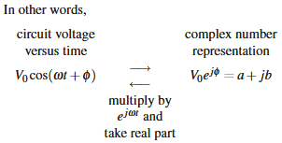

j is used instead of i to not confused it with small-signal current. It’s still the x axis, even though we use j.

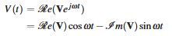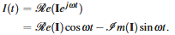

Example:
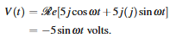

1.7.4: Reactance of capacitors and inductors
Impedance is an imaginary (Complex?) value for capacitors and inductors: Z = R - jX

A circuit containing only capacitor and inductors always has a purely imaginary impedance, since voltage and current are always 90 degrees out of phase.

I don’t understand the mathematics here to first principles, and that’s for the future.

1.7.5: Ohm’s law generalized
V = IZ

This all still follows the same resistor rules:
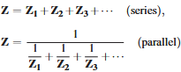

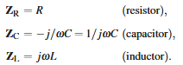

Power delivered to a capacitor over a full cycle is zero:
In A and C power is being deliver and it’s being charged.
In B and C power is being drained and it’s being discharged.
Hence, average power is zero.
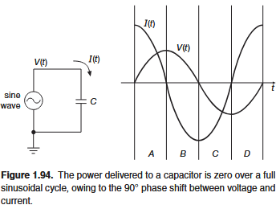

The average power to any purely reactive circuit element (inductor, capacitor, combinations) is always zero. This is because it’s exactly 90 degrees out of phase.

You can get average power for an arbitrary circuit by integrating over one period:
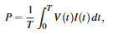

Or, complex multiplication with a few conjugates (to keep it real):

Calculated power is always equal to or less than the magnitudes of V and I. This is power factor!!!

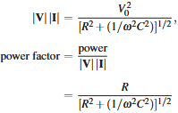

Power factor of 0 is a purely reactive circuit. 1 is a purely resistive circuit.

Reactive currents don’t result in useful power being delivered to the load, but they do cost the power company because of I²R resistance.

Residential power is billed only for the “real” power (ReVI*), but industrial users are billed accord to the power factor. This explains capacitor yards behind large factories, which are built to cancel the inductive reactance of industrial machinery (eg. motors).

1.7.7: Voltage dividers generalized
Generalize a voltage divider by replacing either or both components with a capacitor or inductor (or any complicated RLC network).

All the same computations as resistor voltage dividers apply:
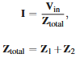
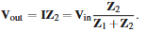

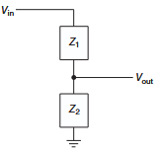

1.7.8: RC highpass filters
The formula for the frequency response of a highpass filter was derived:
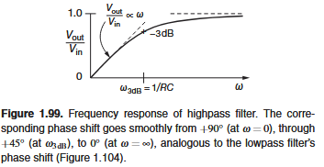

Oscilloscopes have an AC coupling mode that is just an RC high-pass filter with the bend at about 10 Hz. This allows you to see small AC signals riding on a large dc voltage.

The -3dB point is called the “breakpoint” of a filter. f_{3dB} = 1/2πRC

1.7.9: RC lowpass filters
Lowpass filters are often used in audio amplifiers to eliminate interference from nearby radio and television stations (0.5-800 MHz).

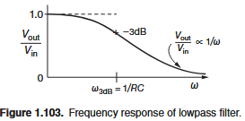

1.7.10: RC differentiators and integrators in the frequency domain
The RC differentiator is exactly the same circuit as the highpass filter.

The circuit can be thought of either depending on if you’re thinking of waveforms in the time domain or response in the frequency domain.

Earlier we saw that we want Vout << Vin. This means we want RC << 1/w.
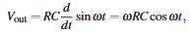

1.7.11: Inductors versus Capacitors
Capacitors can also be combined with resistors to create lowpass or highpass filters.

Inductors are more bulky and expensive than capacitors and perform less well (depart further from ideal).

“If you have a choice, use a capacitor.”

An RF coke is an inductor, usually a few turns of wire wound on a ferrite core. This raises impedance at very high frequencies to prevent oscillations.

Inductors are essential in LC tuned circuits and switch-mode power converters (chapter 9).

1.7.12: Phasor diagrams
Phasor diagram axis are the real (resistive) and imaginary (reactive) components of the impedance.

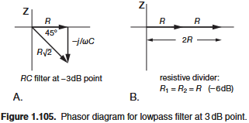

In a series circuit current is the same everything, so the axes also represent the (complex) voltage.

The phasor diagram above is for an RC voltage divider.
The input voltage (applied across the series RC pair) is proportional to the length of the hypotenuse.
Output voltage (across R) is proportional to the length of the R leg of the triangle.

1.7.13: “Poles” and decibels per octave
An octave is a doubling of frequency. As in music.

For an RC lowpass filter, output amplitude is dropping proportional to 1/f.

Every octave the output amplitude drops by a half, or -6dB.

So, the falloff of a simple RC filter is 6 dB/octave.

Filters made with several RC section can have higher drop offs. Eg. two sections gets you 12 dB/octave, 3 = 18, etc.

The response function we derived earlier for simple RC filters was based on a zero-impedance driving source and an infinite-impedance load.

Infinite-impedance means no AC current gets through, only pure DC.

1.7.14: Resonant circuits
Active filters are combinations of inductors and capacitors. They have a large peak in the response at a particular frequency.

Useful in Audio and RF.

Think of this as a voltage divider with an LC impedance component:
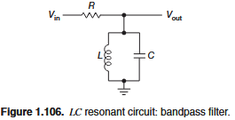

The impedance of the parallel LC path:
Notice that impedance goes to infinity at the resonant frequency.
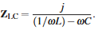

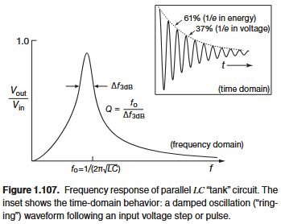

In practice, losses in the inductor and capacitor limit the sharpness of the peak. Also, a Q-spoiling resistor can be used to intentionally reduce the sharpness of the peak.

This circuit is called a parallel LC resonant circuit (tuned circuit).

Higher driving impedance means a sharper peak.

Quality factor (Q) measured the sharpness of the peak. IT equals resonant frequency divided by the width at -3 dB. For a parallel RLC circuit, Q = w₀RC.

Or, Q = R/X_{C} = R / X_{L} where X_{L} = X_{C} at reactances at w₀ (resonant frequency)

Chapter 1x of the advanced volume is coming up a lot, I should look at it.

The LC notch filter (“trap”) removes a particular frequency:
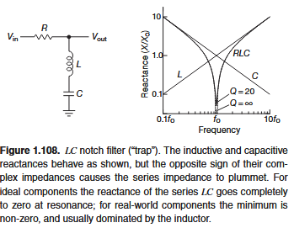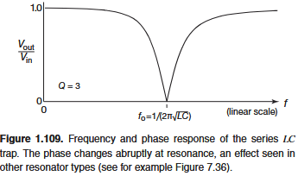

Near the resonant frequency, impedance goes to zero and the signals at a particular frequency are shorted to ground.

Confusing tbh. Figure it out if necessary for future RF projects.

For LC notch filter:
Q = w₀L/R

Quality factors:
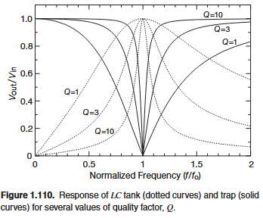

Everything so far was in the frequency domain, now in the time domain:
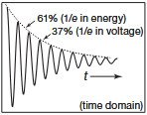

Above you see that signal voltage falls to 1/e in Q/π.
Stored energy (proportional to v²) falls to 1/e in Q/2π cycles.

Other ways to get frequency-selective circuit behaviour is through quartz-crystal, ceramic, and surface acoustic-wave resonators, transmission lines, and resonant cavities.

1.7.15: LC filters
With inductors and capacitors you can get far sharper frequency responses than with an RC filters (or cascaded RC sections). More in chapter 6 (this isn’t on the critical path to any near-term projects).

This is a mixed-digitizer board they built for radio receiver project:
The lowpass filter has 3 inductors and 4 capacitors (7-section), design to cut off at 1.0MHz.
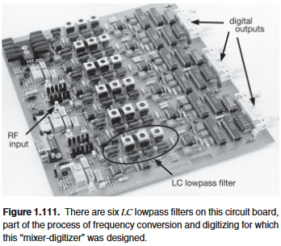

This shows the performance of the 7-section LC lowpass filter compared to an RC lowpass filter (barely a filter at all):
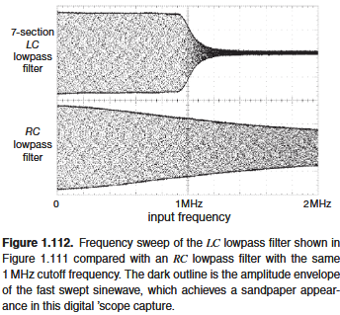

1.7.16: Other capacitor applications
Bypassing:
- Allow a dc voltage but no signals.
- Select capacitance such that impedance at signal frequencies is small compared with what it is bypassing.
- Place it across a circuit element.
- So it goes to ground?

Power-supply filtering:
- Large value capacitors are called storage capacitors
- Used in rectifier circuits
- This is what you see in rectifier circuits on PCBs!

Timing and waveform generation:
- A capacitor supplied with a constant current charges up with a ramp waveform (remember the fundamental capacitor equation! The differential capacitor equation! Nvm the fundamental one is Q=CV, not the one I was thinking of, the differential capacitor equation)
- This is the basis of ramp and sawtooth generators, used in analog function generators, analog-digital converters, timing circuits.
- RC circuits are used for timing, basis of delay circuits (monostable multivibrators).

1.7.17: Thevenin theorem generalized
Starting to realize how much of a reference text this is, not a textbook. Textbook would go into a ton of detail into Thevenin and tons of examples. This is higher level.

Restarting Thevenin for capacitors and inductors:
“any two-terminal network of resistors, capacitors, inductors, and signal sources is equivalent to a single complex impedance in series with a single signal source.”

1.8: Putting it all together - an AM radio
This was all made for a course! Remember! This chapter is tied up by hooking up a simple AM radio.

It’s an AM radio with an RF carrier.

An audio waveform described by f(t) would be transmitted as an RF signal like so:

The constant A is added so that the coefficient is never negative. A negative amplitude means nothing.

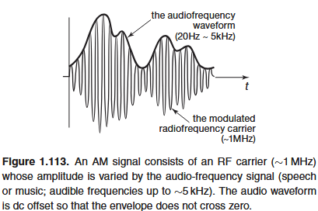

I finally understand the carrier signal!

Can I characterize the RF signals around me? Fun project! Just get a sweep of amplitudes for a given frequency? What did I just type? How to differentiate noise?

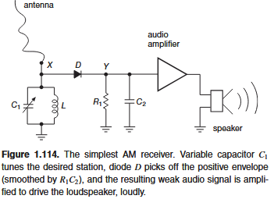

Simplest AM receiver explained:
- The parallel LC resonant circuit is tuned ot the station’s frequency.
- The diode is a half-wave rectifier which only phases positive half-cycles.
- R₁ provides a light load so the rectified output follows the half-cycles back down to zero
- C₂ prevents the output from following the fast half-cycles of the carrier
- A time constant R₁C₂ is chosen that is long compared to the carrier period (~1us) but short compared to the period of the highest audio frequency (~200us)

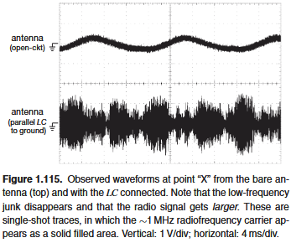

The amplitude of the selected station increases because the resonant circuit’s high Q is storing energy from multiple cycles of the signal.

Grok:
- High Q factor means low losses (low resistance) and narrow bandwidth
- Q = f₀ / df where f₀ is the resonant frequency and df if the bandwidth (range of frequencies this circuit responds to)
- High Q means small df, so tuned sharply to a particular AM frequency.
- The inductor and capacitor exchange energy back nad forth at the resonant frequency, building up a larger voltage across the circuit than the voltage from the radio wave alone.
- Resonation means voltage across the LC tank can be Q times larger than the input voltage. “Resonant voltage rise.”
- The resonant circuit doesn’t instantly reach its max amplitude. Multiple cycles are required.
- Higher Q means more cycles required

Audio amplifiers coming later:
With discrete transistors in chapter 2 and opamps in chapter 4.

In class, they sometimes use a cable with a capacitance of about 30 pF/ft. This adds to C₁. This means a different resonant frequency so tuning to a different station. If they choose right they can get to a different language. Laughter in class ensues.

1.9: Other passive components
Toggle switches:
- Various configurations depending on number of poles.
- Pole = input you can control with the switch
- Throw = output
- “Break before make” the contact never connects to two terminals

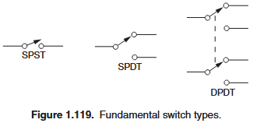

Pushbutton switches:
- NO = normally open
- NC = normally closed

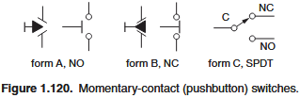

Rotary switches:
- Shorting = make-before-beak
- Non-shorting = break-before-make
- Arbitrary many poles and positions
- Some rotary switches encode position as a 4-bit binary quantity. Only 5 wires requires (4 bits and a common line)

PC-mounting switches:
- PC = “printed circuit” boards
- DIP = dual in-line package
- PCB mounted switches are DIP switches here

Other switch types:
- Exotic switches: hall-effect switches, reed switches, proximity switches, etc.
- All switches have voltage and current ratings
- Operation with inductive loads reduces switch ilf because of arcing during turn-off
- Some switches rely on current flow to clean away contact oxides (minimum current required to keep these operational).
- “Dry switching” switches exist for low-level signals. (gold contact plating)

Is this how all light switches work?!?!?!
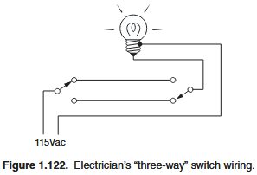

1.9.2: Electromechanical devices: relays
Coil pulls an armature to close contacts when sufficient coil current flows.

Latching relay: maintains state
Stepping relay: Advances through a sequence of states with each input pulse (ratchet or rotary mechanism)

Stepping relays were fundamental to telephone exchanges (the Strowger selector).

Mercury-wetted and reed relays are used for high-speed switching (~1ms).

Solid-state relays (SSR) are turned on by an LED. No contact bounce.

Relays are most useful in high-voltage switches where it’s import to have complete electrical isolation.

1.9.3: Connectors
Connectors are usually the most unreliable part?

Single-wire connectors:
- Pin jack or banana jack used on multimeters, etc.

Shielded-cable connectors:
- Shielded coaxial cables prevent capacitive pickup
- BNC type is one from Phys 159
- TNC is similar to BNC but has a threaded outer shell
- The phono jack used in audio equipment has the inner signal conductor mate before the shield (ground). Lesson in bad design.

“We hereby induct these losers into the Electronic Components Hall of Infamy.”

Hall of infamy:
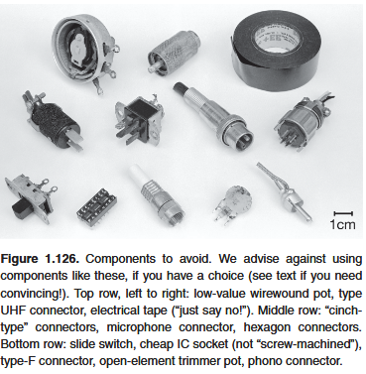

Card-edge connectors:
- Gold-plated contacts at the edge of a PCB

1.9.4: Indicators
Meters:
- Two choices: moving-pointer meter or digital-readout meter
- “The latter are more expensive and more accurate.” lmao not anymore!
- Increasingly we’re seeing LCDs or LED panels. Still funny

Lamps, LEDs, and displays:

Small incandescent lamps used to be used in front-panel indicators, since replaced by LEDs. How the early control panels must have looked!

LEDs are diodes but with higher forward voltage drops:
2.5-2V for red, orange, some greens.
Blue has 3.6V (gallium nitride blue LED was a breakthrough by Shuji Nakamura, rewatch that Veritasium video)

2-10mA produces adequate brightness in LEDs.

White LEDs are usually a blue LED with a yellow fluorescent coating. I should beak apart a white LED.

LED backlights aren’t particularly low power.

1.9.5: Variable components
Variable resistors:
- “Good advice: resist the temptation to use lots of trimmers in your circuits. Use good design instead.”
- All-electronic potentiometers are made with an array of transistor switches that select a tap in a long chain of fixed resistors. Perfectly workable when inside an IC.
- Some all-electronic pots are non-volatile for TVs, etc. Useful for infrared volume control.
- Potentiometers are not as stable as good (1%) resistors. Don’t use them in place of resistors.
- If you need a precise resistance somewhere, do it with a good resistor in series with a potentiometer.

“Keep an open mind when design brainstorming.”

Variable capacitors:
- Usually up to 1000pF, 1nF
- Diodes operating with applied reverse voltage can be used as voltage-variable capacitors. (varactors or varicaps).

Variable inductors:
- Made by moving core material in a fixed coil. uH to H available.
- The varimeter was a rotatable coil positioned inside a fixed outer coil and connected in series. As the inner coil rotated, total inductance charged.

Variable transformers:
- High voltage AC transformers named variacs by General Radio.
- The output of these is not electrically isolated from the power line, as it would be with a transformer.
- This is because they’re configured as autotransformers where they only have one winding with a sliding contact.

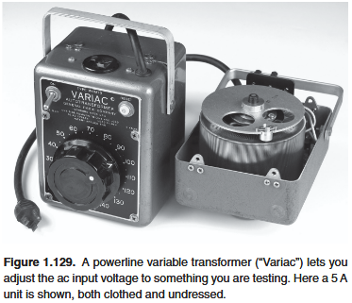

1.10: A parting shot: confusing markings and itty-bitty components
They complain about capacitor markings too!

Some capacitors omit the units and print the value as an integer (“470” meaning 470pF) and some use exponent notation (“470” meaning 47*10⁰ = 47pF)

4-digit date code (yydd) often mistaken for a part number.

1.10.1: Surface-mount technology: the joy and the pain
“While we’re complaining, let’s whine just a bit about the difficulty of prototyping circuits with tiny surface-mount components.”

SMD components are low inductance.

“Sadly, we cannot ignore this disturbing trend, because the majority of new components are offered only in surface-mount packages. Woe to the lone basement experimenter–inventor.”

– en dash! Not em or hyphen

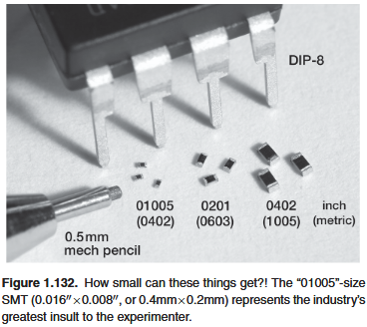

TWO: Bipolar Transistors

2.1: Introduction
A transistor is an active component, a device that can amplify a signal.

The additional power of the output over the input comes from an external power source.

A transistor is a power amplifier.

ICs are just a ton of transistors. And ICs replaced a bunch of discrete transistors.

Two primary species of transistors:
- Bipolar Junction Transistors (BJTs)
- Field-effect Transistors (FETs)

BJTs were invented in 1947 at Bell Labs, got a Nobel Prize.

BJTs excel in accuracy and low noise, FETs excel in low power, high impedance, high-current switching.

h-parameter model and equivalent circuit is the most common way to describe bipolar transistors. This book doesn’t do that. Instead, Eber-Moll equations.

V_{C} = Collector voltage
V_{BE} = Base-to-emitter voltage drop
V_{CC} = power-supply voltage associated with the collector

Transistors have two independent voltages and two independent currents. More complicated that earlier circuits.

2.1.1: First transistor model: current amplifier
A bipolar transistor has three terminals.

A small current applied to the base controls a larger current flowing between the collector and emitter.

Two varieties: npn, pnp

Rules for / properties of npn transistors:
- Collector must be more positive than emitter
- The base-emitter and base-collector circuits behave like diodes
- Base-emitter diode is normally conducting, while base-collector diode is reverse-biased (ie. voltage applied is in the opposite direction to easy current flow).
- Maximum limits: I_{C}, I_{B}, V_{CE}, V_{BE}, temperature.
- I_{C} is proportional to I_{B}:
Where β is the current gain, typically 100.
I_{B} and I_{E} flow to the emitter.

For pnp properties, reverse all polarities

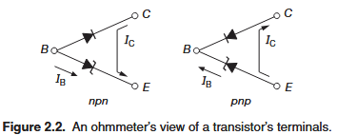

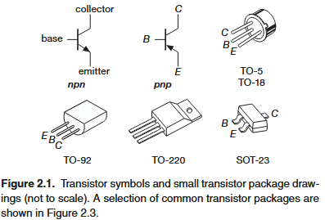

Above we saw that a smaller current flowing into the base controls a larger current flowing into the collector.

The β current gain value is not a constant, it varies from 50-250 depending on the transistor and the circuit. Don’t depend on it. See:
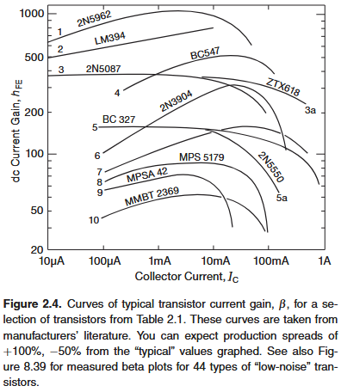

The V_{BE} diode means that you must have V_{B} ~= V_{E} + 0.6V

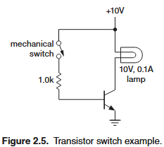

Consider the circuit above.

With the switch closed, the base rises to 0.6V (because of the forward voltage of the diode and ground). This means V_{resistor} is 9.4V, V/R = I = 9.4mA.

Applying a default beta value of 100, we get I_{C} = 940mA.

This is wrong because multiplying by the beta value over works if Rule 1 is obeyed: collector must be more positive than the emitter. At 100mA the lamp has 10V across it, so collector voltage equals emitter voltage equals ground. So, I_{C} = 100mA in this case, dependent on the external circuit.

This is called saturation. The collector goes as close to ground as possible (typical saturation voltages are 0.05V - 0.2V, i think this means above ground).

This means in our case we are over driving the base. It’s getting 9.4mA when 1.0mA would have sufficed. We’re doing this because the resistance of a lamp when cold is 5-10x lower than at operating current. Also, transistor beta drops at low collector-to-base voltages.

A 10k is usually across base and ground. 0.06mA used during operation.

Cautions when designing transistor switches:
- Choose base resistor conservatively to get excess base current.
- If the load swings below ground (eg. AC or inductive) use a diode in series with the collector to prevent collector-base conduction on negative swings.
- For inductive loads, protect the transistors with a diode across the load (see image below). Without the diode, the collector will get a large positive voltage when the switch it opened, exceeding the collector-emitter breakdown voltage.

A higher base resistor is also good for high-speed switching because of capacitive effects and reduced beta at very high frequencies (megahertz). Usually a few picofarad capacitor is connected across the base resistor to improve high-speed performance, it acts as a short initially.

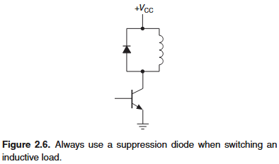

Why both with a transistor when a mechanical switch would work;
- Transistor can be driven electrically
- Transistor switch rapidly, factions of microseconds
- Many circuits can be switched using a single control signal
- Mechanical switches bounce and suffer from wear.

Bounce can break a circuit a few dozen times in the first few milliseconds

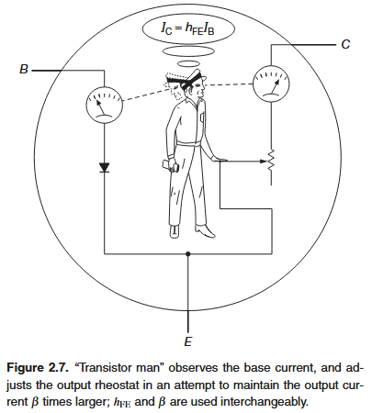

Transistor man changes the potentiometer to keep I_{C} = βI_{B}. He can go from short circuit (saturation) to open circuit (transistor off state). It isn’t actually a resistor, so idk why they’re suing this example.

2.2.2: Switching circuit examples
Linear (mathematical) = the sum of two inputs is the sum of the individual responses.
f(x + y) = f(x) + f(y)

Transistors are non-linear because they are in one of two possible state (cut off, or saturated).

95% of transistors in the world are switches.

Linear circuit examples: amplifiers, current source, integrators.

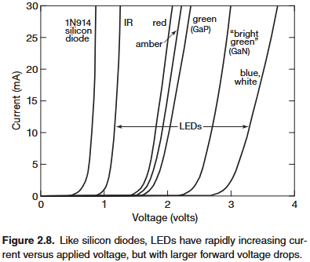

LED Driver:
Light Emitting Diodes have higher forward voltage drops (1.5-3.5V). This is because of different semiconductor materials such as GaAsP, GaAlAs, GaN, which have large bandgaps.

Current increases rapidly for a small increase in voltage after you surpass the forward voltage drop. 10-20mA is enough for far too much light from an LED, blinding.

Chapter 12 has LED driving techniques.

Applying 5V across an LED is guaranteed to blow it out. You need to gently coax it into drawing the right current.

Trying a few sample operating currents to get the right color.

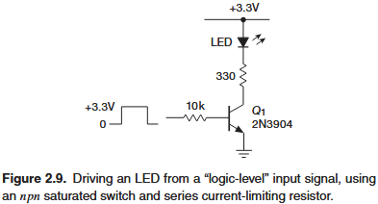

In this sample circuit, we use an npn transistor as a switch.

The collector resistor is chosen to provide the chosen LED current (keep in might that the voltage drop across the resistor is supply voltage minus LED forward drop).

Then, the base resistor is chosen to ensure saturation (assume a low transistor beta like 25).

Notice that we use a 10k base resistor above.
I_{C} = βI_{B}
For I_{C} = 5mA, I_{B} = 0.2mA, I_{B} = V_{B}/R, I_{B} = 3.3/10,000 = 0.33mA, Yes!

Also notice how close that circuit is to what we have on the ECU! It’s just missing the pull-down resistor across base and ground! And the authors mentioned that earlier!

Next chapter, MOSFET-type transistor is often a better choice for this circuit.

Chapters 10-12 show ways to drive LEDs from ICs without external discrete transistors.

Variations on a theme:
The collector is the output of a pnp transistor. pnp’s conduct when the input is ground.

High-side switching circuit:
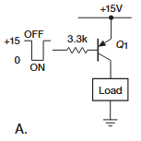

Here we have a pnp transistor (notice the direction of the arrow) with the emitter on the 15V rail and the collector on the load’s high side.

About 4mA flow when the base is brought to 15V (V=IR), with B>50, this is I_{C}>200mA.

This is impractical because we would need 15V to control the load. (Chapters 10-15 explore in more detail).

Grok: https://grok.com/chat/0d8b0c31-eb63-4413-9e30-fdcd02cea769

NPN and PNP transistors are current-controlled switches. MOSFETs are voltage controlled!

The voltage sets up the current, but the I_{B} current does the switching. The voltage initiates the base current.

The base resistor and base-emitter body diode (for npn) system works like a voltage divider. Diode has a 0.7V drop (fixed) and the resistor deals with the rest. Note that the diode is fixed.

To determine base current, you need to use input base voltage minus diode voltage drop. V_{B} = V_{switching} - V_{diode} = 15 - 0.7 = 14.3.
I = V/R = 14.3V / 3300 = 4.33mA

Solution: use npn transistor to cleverly change current going to the base of transistor Q₃.
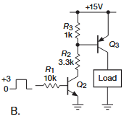

With Q₂ open, R₃ holds Q₃ base high and hence Q₃ is closed.

With Q₂ closed, R₃R₂ act as a voltage divider.

We just need base voltage to be less than 14.3V for Q₃ to be closed.
R₂ / (R₂ + R₃) * 15V = 11.5V
Note that it is a current controlled switch, so you do need current, but you also need to overcome the diode’s forward voltage drop.

Notice that if we used 100 ohms instead of a 3.3k we get:
3300 / (3300 + 100) * 15V = 14.56V
Now, Q₃ remains closed. So, you must you a big enough R₃ resistor.
A 1:1 ratio should be fine.

Because Q₃ is a pnp, current wants to flow from its emitter to base. Because Q₂ is initially disconnected, this current has no place to go.

R₃ pulls Q₃ base toward 15V. Because V_{BE} ~= 0.7V, Q₃ base would be ~14.3V. No current flows and the switch it open.

When Q₂ conducts, it’s collector is brought to the emitter voltage plus V_{CE} ~= 0.2. So the collector is at 0.2V.

Some current flows from the Q₃’s emitter-base diode and some flows through resistor R₃. To determine how much, calculate R₃ current, subtract this from Q₂ current, and Q₃ emitter-base current is what’s remaining. How to find Q₂ current? Who knows?

For future reference:
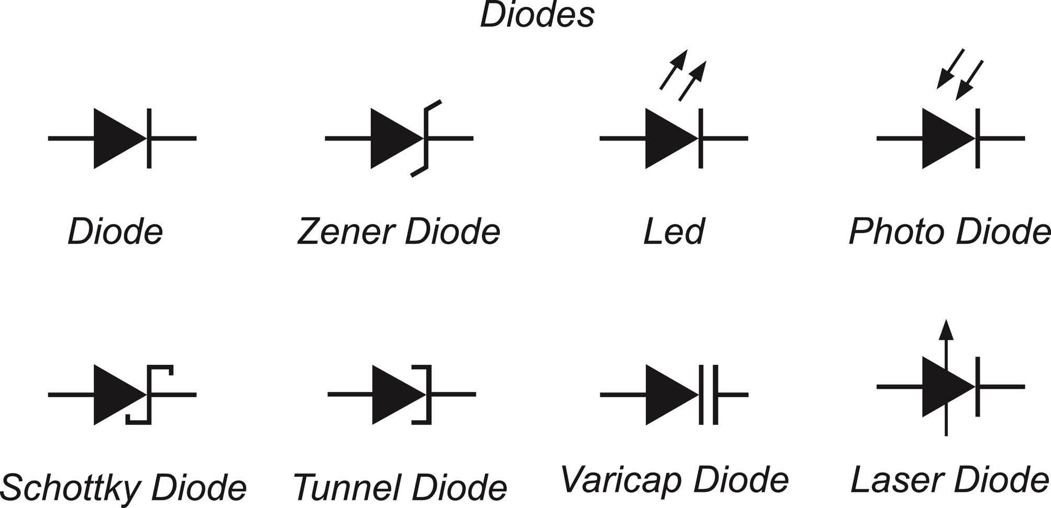

Note: Diodes aren’t “closed” or “open” they “conduct” or don’t.

Pulse generator - I
This section is called “Some basic transistor circuits” lmao

